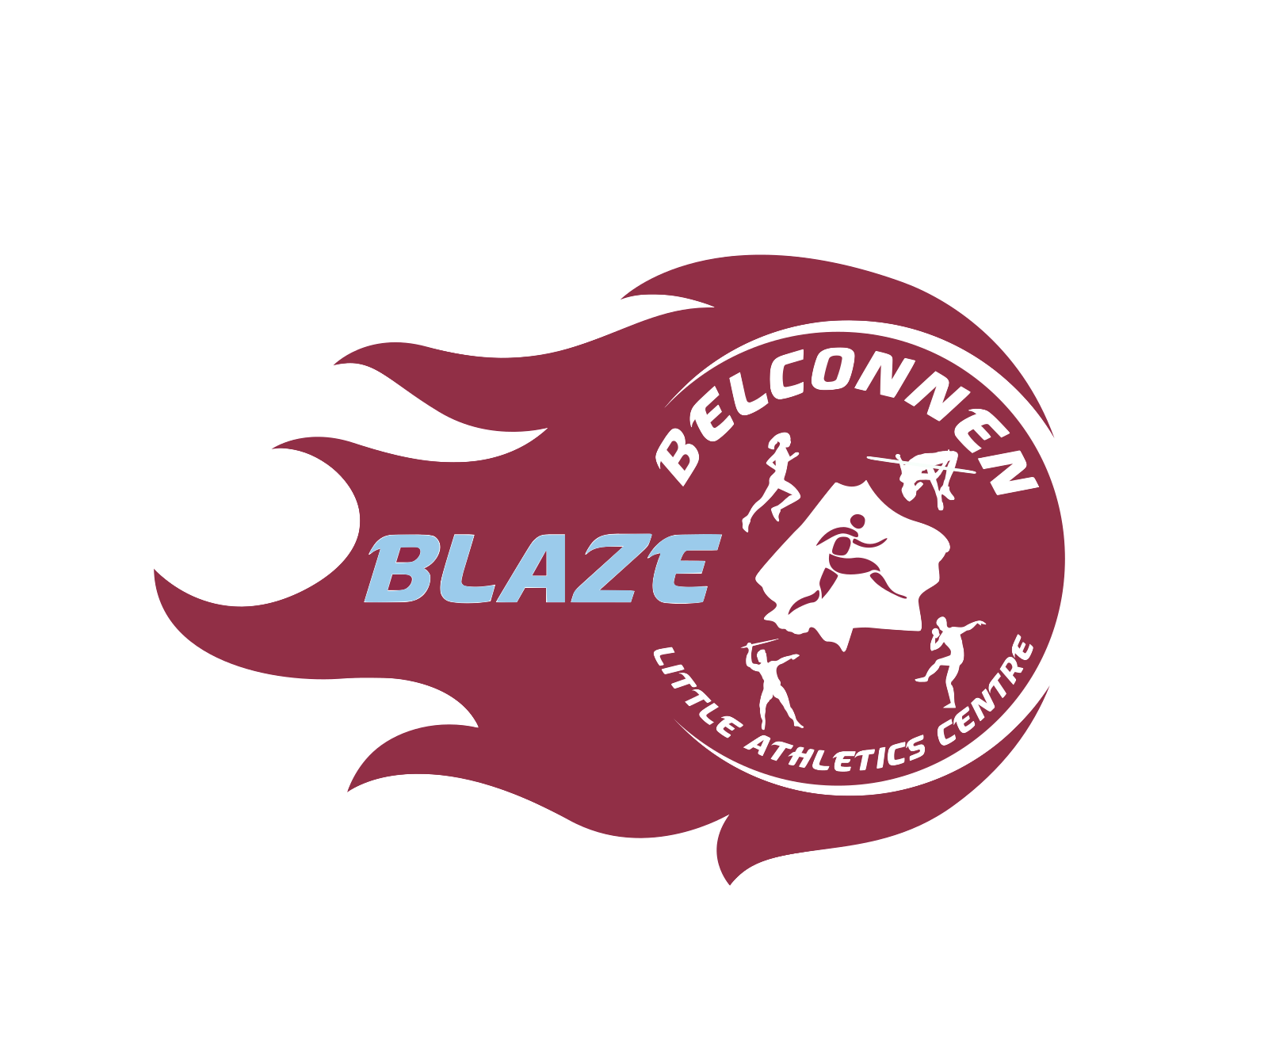

**BELCONNEN LITTLE ATHLETICS**



# **PROGRAM 1**

| **Age Group** | **Event 1** | **Event 2** | **Event 3** | **Event 4** | **Event 5** |
| --- | --- | --- | --- | --- | --- |
| **Under 6G** | 50m | Discus (Area 1)  Discus (Throws 4) | 100m | 300m | Vortex (Jav 3)  Vortex (Jav 4) |
| **Under 6B** | 50m | 100m | Vortex (Jav 3)  Vortex (Jav 4) | Discus (Area 1)  Discus (Throws 4) | 300m |
| **Under 7G** | 50m | Vortex (Jav 3)  Vortex (Jav 4) | 70m | 200m | Long Jump (Pit 2)  Long Jump (Pit 3) |
| **Under 7B** | Long Jump (Pit 2)  Long Jump (Pit 3) | 50m | 70m | Vortex (Jav 3)  Vortex (Jav 4) | 200m |
| **Under 8G** | Shot Put (Area 2)  Shot Put (Throws 3) | 100m | 300m | Long Jump (Pit 2)  Long Jump (Pit 3) | Turbo Jav (Jav 1)  Turbo Jav (Jav 2) |
| **Under 8B** | 50m | Turbo Jav (Jav 1)  Turbo Jav (Jav 2) | 300m | High Jump (Area 2) | 100m |
| **Under 9G** | High Jump (Area 2) | 100m | Discus (Area 1)  Discus (Throws 4) | 200m | Shot Put (Area 2)  Shot Put (Throws 3) |
| **Under 9B** | 100m | Shot Put (Area 2)  Shot Put (Throws 3) | High Jump (Area 2) | 200m | Discus (Area 1)  Discus (Throws 4) |
| **Under 10G** | Discus (Area 1)  Discus (Throws 4) | 800m | Long Jump (Pit 2)  Long Jump (Pit 3) | 100m | 200m |
| **Under 10B** | Discus (Area 2) | 800m | Long Jump (Pit 1) | 100m | 200m |
| **Under 11G** | 800m | Long Jump (Pit 2)  Long Jump (Pit 3) | Shot Put (Area 1) | Javelin (Jav 1) | 200m |
| **Under 11B** | 800m | Shot Put (Area 1) | Javelin (Jav 1) | Long Jump (Pit 1) | 200m |
| **Under 12G** | Long Jump (Pit 1) | 800m | High Jump (Area 1) | Discus (Area 2) | 100m |
| **Under 12B** | Shot Put (Area 1) | 800m | Discus (Area 2) | 200m | High Jump (Area 1) |
| **Under 13G** | High Jump (Area 1) | 800m | 100m | Shot Put (Area 1) | 200m |
| **Under 14-17G** | 800m | Discus (Area 2) | Javelin (Jav 2) | 100m | Long Jump (Pit 1) |
| **Under 13-17B** | 800m | Long Jump (Pit 1) | 100m | Javelin (Jav 2) | Discus (Area 2) |

# **BELCONNEN LITTLE ATHLETICS**



# **PROGRAM 2**

| **Age Group** | **Event 1** | **Event 2** | **Event 3** | **Event 4** | **Event 5** |
| --- | --- | --- | --- | --- | --- |
| **Under 6G** | 70m | Long Jump (Pit 2)  Long Jump (Pit 3) | Vortex (Jav 3)  Vortex (Jav 4) | 200m | 100m |
| **Under 6B** | 70m | Discus (Area 1)  Discus (Throws 4) | 100m | Long Jump (Pit 2)  Long Jump (Pit 3) | 200m |
| **Under 7G** | Shot Put (Area 2)  Shot Put (Throws 3) | 70m | Discus (Area 1)  Discus (Throws 4) | 500m | 100m |
| **Under 7B** | Vortex (Jav 3)  Vortex (Jav 4) | 70m | 500m | Shot Put (Area 2)  Shot Put (Throws 3) | 100m |
| **Under 8G** | High Jump (Area 2) | 100m | 400m Walk | 50m | Discus (Area 1)  Discus (Throws 4) |
| **Under 8B** | Discus (Area 1)  Discus (Throws 4) | 100m | Long Jump (Pit 2)  Long Jump (Pit 3) | 400m Walk | Shot Put (Area 2)  Shot Put (Throws 3) |
| **Under 9G** | 70m | Turbo Jav (Jav 3)  Turbo Jav (Jav 4) | 700m Walk | 200m | Long Jump (Pit 2)  Long Jump (Pit 3) |
| **Under 9B** | Long Jump (Pit 2)  Long Jump (Pit 3) | 70m | 700m Walk | Turbo Jav (Jav 3)  Turbo Jav (Jav 4) | 200m |
| **Under 10G** | 70m | 1,100m Walk | High Jump (Area 2) | Turbo Jav (Jav 1)  Turbo Jav (Jav 2) | 100m |
| **Under 10B** | Turbo Jav (Jav 2) | 1,100m Walk | Shot Put (Area 2)  Shot Put (Throws 3) | 70m | High Jump (Area 2) |
| **Under 11G** | High Jump (Area 1) | 1,100m Walk | 100m | Discus (Area 1)  Discus (Throws 4) | 400m |
| **Under 11B** | Discus (Area 2) | 1,100m Walk | 100m | 400m | High Jump (Area 1) |
| **Under 12G** | 1,500m Walk | Javelin (Jav 1) | Shot Put (Area 1) | 100m | 200m |
| **Under 12B** | 1,500m Walk | Long Jump (Pit 1) | 100m | Discus (Area 2) | Javelin (Jav 1 or 2) |
| **Under 13G** | 1,500m Walk | Discus (Area 2) | Triple Jump (Pit 1) | 200m | Javelin (Jav 1 or 2) |
| **Under 14-17G** | 1,500m Walk | Shot Put (Area 1) | High Jump (Area 1) | Triple Jump (Pit 1 or 2) | 200m |
| **Under 13-17B** | 1,500m Walk | High Jump (Area 1) | 200m | Triple Jump (Pit 1 or 2) | Shot Put (Area 1) |

**BELCONNEN LITTLE ATHLETICS**

# **PROGRAM 3**

| **Age Group** | **Event 1** | **Event 2** | **Event 3** | **Event 4** | **Event 5** |
| --- | --- | --- | --- | --- | --- |
| **Under 6G** | 50m | Discus (Area 1)  Discus (Throws 4) | 70m | 300m | Shot Put (Area 2) |
| **Under 6B** | Vortex (Jav 3)  Vortex (Jav 4) | 50m | 70m | 300m | Shot Put (Throws 3) |
| **Under 7G** | Shot Put (Area 2)  Shot Put (Throws 3) | 50m | Long Jump (Pit 2)  Long Jump (Pit 3) | 70m | Vortex (Jav 3)  Vortex (Jav 4) |
| **Under 7B** | Long Jump (Pit 2)  Long Jump (Pit 3) | 70m | 100m | 50m | Discus (Throws 3)  Discus (Shot Area 2) |
| **Under 8G** | 50m | Long Jump (Pit 2)  Long Jump (Pit 3) | Discus (Area 1)  Discus (Throws 4) | Turbo Jav (Jav 3)  Turbo Jav (Jav 4) | 200m |
| **Under 8B** | 50m | Shot Put (Area 2)  Shot Put (Throws 3) | High Jump (Area 2) | 200m | Discus (Area 1)  Discus (Throws 4) |
| **Under 9G** | High Jump (Area 2) | 800m | Shot Put (Area 2)  Shot Put (Throws 3) | Discus (Area 1)  Discus (Throws 4) | 70m |
| **Under 9B** | Discus (Area 1)  Discus (Throws 4) | 800m | 70m | Shot Put (Area 2)  Shot Put (Throws 3) | High Jump (Area 2) |
| **Under 10G** | 70m | Turbo Jav (Jav 3)  Turbo Jav (Jav 4) | 400m | Shot Put (Area 1)  Shot Put (Area 2**) | Long Jump (Pit 2)  Long Jump (Pit 3) |
| **Under 10B** | Turbo Jav (Jav 1) | 70m | 400m | Long Jump (Pit 3) | Shot Put (Area 1) |
| **Under 11G** | 1,500m | Triple Jump (Pit 1) | Shot Put (Area 1) | 100m | Javelin (Area 1 or 2) |
| **Under 11B** | 1,500m | Javelin (Jav 2) | Discus (Area 2) | Triple Jump (Pit 1) | 100m |
| **Under 12G** | 1,500m | High Jump (Area 1)  (combined conduct) | 200m | Triple Jump (Pit 2) | Discus (Area 2) |
| **Under 12B** | 1,500m | 100m | 200m | Triple Jump (Pit 1 or 2) |
| **Under 13G** | Shot Put (Area 1) | 1,500m | Long Jump (Pit 1) | 100m | High Jump (Area 1) |
| **Under 14-17G** | Long Jump (Pit 1) | 1,500m | Javelin (Jav 2) | Discus (Area 2) | 100m |
| **Under 13-17B** | Discus (Area 2) | 1,500m | Javelin (Jav 1) | 100m | Long Jump (Pit 1) |

*\*\* If space available*

# 

# **BELCONNEN LITTLE ATHLETICS**



# **PROGRAM 4**

| **Age Group** | **Event 1** | **Event 2** | **Event 3** | **Event 4** | **Event 5** |
| --- | --- | --- | --- | --- | --- |
| **Under 6G** | Long Jump (Pit 2)  Long Jump (Pit 3) | Vortex (Jav 3)  Vortex (Jav 4) | 300m | Shot Put (Area 2)  Short Put (Throws 3) | 70m |
| **Under 6B** | Shot Put (Area 2)  Shot Put (Throws 3) | 300m | Vortex (Jav 3)  Vortex (Jav 4) | 70m | Long Jump (Pit 2)  Long Jump (Pit 3) |
| **Under 7G** | 500m | Discus (Area 1)  Discus (Throws 4) | 100m | Vortex (Jav 3)  Vortex (Jav 4) | 200m |
| **Under 7B** | 500m | Shot Put (Area 2)  Shot Put (Throws 3) | Discus (Area 1)  Discus (Throws 4) | 200m | Vortex (Jav 3)  Vortex (Jav 4) |
| **Under 8G** | 60m Hurdles | 700m | Shot Put (Area 2)  Shot Put (Throws 3) | High Jump (Area 2) | 70m |
| **Under 8B** | 60m Hurdles | 700m | Long Jump (Pit 2)  Long Jump (Pit 3) | 70m | Turbo Jav (Jav 1)  Turbo Jav (Jav 2) |
| **Under 9G** | 60m Hurdles | Long Jump (Pit 2)  Long Jump (Pit 3) | Turbo Jav (Jav 1)  Turbo Jav (Jav 2) | 400m | 100m |
| **Under 9B** | Turbo Jav (Jav 3)  Turbo Jav (Jav 4) | 60m Hurdles | 400m | Long Jump (Pit 2)  Long Jump (Pit 3) | 100m |
| **Under 10G** | High Jump (Area 2) | 60m Hurdles | 200m | Discus (Area 1)  Discus (Throws 4) | Shot Put (Area 2)  Shot Put (Throws 3) |
| **Under 10B** | Discus (Area 1) | 60m Hurdles | High Jump (Area 2) | 200m | 100m |
| **Under 11G** | Long Jump (Pit 1) | 80m Hurdles | 200m | High Jump (Area 1) | Discus (Area 2) |
| **Under 11B** | Shot Put (Area 1) | 80m Hurdles | Long Jump (Pit 1) | 200m | High Jump (Area 1) |
| **Under 12G** | Javelin (Jav 1) | Long Jump (Pit 1) | 400m | 80m Hurdles | Shot Put (Area 1) |
| **Under 12B** | Javelin (Jav 2) | 400m | 80m Hurdles | Shot Put (Area 1) | Long Jump (any pit) |
| **Under 13G** | Discus (Area 2) | Javelin (Jav 2) | 400m | 80m Hurdles | Long Jump (any pit) |
| **Under 14-17G** | High Jump (Area 1)  combined conduct | Shot Put (Area 1) | 400m | 13B/14G – 80m Hurdles  14B/15G/16G – 90m Hurdles  15B/16B/17G/17B – 100m Hurdles | 200m |
| **Under 13-17B** | 400m | Shot Put (Area 1) | 200m |



# **BELCONNEN LITTLE ATHLETICS**



# **PROGRAM 5 - CROSS COUNTRY PROGRAM**

| **Age Group** | **Event 1** | **Event 2** | **Event 3** | **Event 4** | **Event 5** |
| --- | --- | --- | --- | --- | --- |
| **Under 6G** | On Track Program | | | | |
| **Under 6B** | On Track Program | | | | |
| **Under 7G** | Cross country course | Discus (Area 1)  Discus (Throws 4) | 50m | Vortex (Jav 3)  Vortex (Jav 4) | 100m |
| **Under 7B** | Cross country course | Vortex (Jav 3)  Vortex (Jav 4) | 50m | Shot Put (Area 2)  Shot Put (Throws 3) | 100m |
| **Under 8G** | Cross country course | 50m | High Jump (Area 2) | 100m | Discus (Area 1)  Discus (Throws 4) |
| **Under 8B** | High Jump (Area 2) | Cross country course | Discus (Area 1)  Discus (Throws 4) | 50m | 100m |
| **Under 9G** | 70m | Long Jump (Pit 2)  Long Jump (Pit 3) | Cross country course | 100m | High Jump (Area 2) |
| **Under 9B** | 70m | Shot Put (Area 2)  Shot Put (Throws 3) | Cross country course | 100m | Long Jump (Pit 2)  Long Jump (Pit 3) |
| **Under 10G** | Discus (Area 1)  Discus (Throws 4) | 100m | Cross country course | Long Jump (Pit 2)  Long Jump (Pit 3) | 70m |
| **Under 10B** | Shot Put (Area 2) | 100m | Cross country course | Turbo Jav (Jav 1)  Turbo Jav (Jav 2) | 70m |
| **Under 11G** | 100m | Javelin (Jav 1) | Cross country course | Discus (Area 2) | Triple Jump (Pit 1 or 2) |
| **Under 11B** | 100m | Javelin (Jav 2) | Shot Put (Area 1) | Cross country course | Triple Jump (Pit 1 or 2) |
| **Under 12G** | Javelin (Jav 1) | 100m | Triple Jump (Pit 1 or 2) | Cross country course | Discus (Area 2) |
| **Under 12B** | Javelin (Jav 2) | 100m | Discus (Area 2) | Cross country course | Shot Put (Area 2) |
| **Under 13G** | Discus (Area 2) | 100m | Triple Jump (Pit 1 or 2) | Cross country course | Shot Put (Area 1) |
| **Under 14-17G** | Shot Put (Area 1) | Discus (Area 2) | 100m | Cross country course | Javelin (Jav 1) |
| **Under 13-17B** | Triple Jump (Pit 1) | Shot Put (Area 1) | 100m | Cross country course | Javelin (Jav 2) |

# **BELCONNEN LITTLE ATHLETICS**



# **PROGRAM 6 - RELAY PROGRAM**

| **Age Group** | **Event 1** | **Event 2** | **Event 3** | **Event 4** |
| --- | --- | --- | --- | --- |
| **Under 6G** | Shuttle Relay (4x50m and 4x70m)  Tiny Tots Frogs to join | On Track Program | | |
| **Under 6B** | On Track Program | | |
| **Under 7G** | Shot Put (Area 2)  Shot Put (Throws 3) | 70m | Long Jump (Pit 2)  Long Jump (Pit 3) |
| **Under 7B** | Long Jump (Pit 2)  Long Jump (Pit 3) | 70m | Shot Put (Area 2)  Shot Put (Throws 3) |
| **Under 8G** | High Jump (Area 2) | Shot Put (Area 2)  Shot Put (Throws 3) | 100m |
| **Under 8B** | 70m | 200m | High Jump (Area 2) |
| **Under 9G** | High Jump (Area 2) | Circular Relay (4 x 100m) | Turbo Jav (Jav 1)  Turbo Jav (Jav 2) | 200m |
| **Under 9B** | Discus (Area 1)  Discus (Throws 4) | Turbo Jav (Jav 3)  Turbo Jav (Jav 4) | 200m |
| **Under 10G** | Turbo Jav (Jav 3)  Turbo Jav (Jav 4) | Long Jump (Pit 2)  Long Jump (Pit 3) | 200m |
| **Under 10B** | Long Jump (Pit 3) | Discus (Area 2) | 200m |
| **Under 11G** | Triple Jump (Pit 1) | 100m | Circular Relay (4 x 100m) | Javelin (Jav 1) |
| **Under 11B** | Triple Jump (Pit 2) | 100m | High Jump (Area 2) |
| **Under 12G** | Shot Put (Area 1) | 100m | Triple Jump (Pit 1) |
| **Under 12B** | High Jump (Area 2) | 100m | Discus (Area 2) |
| **Under 13G** | Javelin (Jav 1) | 100m | Triple Jump (Pit 2) |
| **Under 14-17G** | Discus (Area 2) | 100m | Javelin (Jav 2) |
| **Under 13-17B** | Javelin (Jav 2) | 100m | Shot Put (Area 1) |

# **BELCONNEN LITTLE ATHLETICS**

# **PROGRAM 7 - LONG WEEKEND PROGRAM**

| **Age Group** | **Event 1** | **Event 2** | **Event 3** | **Event 4** | **Event 5** |
| --- | --- | --- | --- | --- | --- |
| **Under 6G** | Discus (Area 1)  Discus (Throws 4) | 70m | Long Jump (Pit 2)  Long Jump (Pit 3) | 50m | Vortex (Jav 3)  Vortex (Jav 4) |
| **Under 6B** | Vortex (Jav 3)  Vortex (Jav 4) | 70m | 50m | Long Jump (Pit 2)  Long Jump (Pit 3) | 200m |
| **Under 7G** | 100m | Vortex (Jav 3)  Vortex (Jav 4) | 50m | 200m | Shot Put (Throws 3)  Shot Put (Area 2) |
| **Under 7B** | Shot Put (Throws 3)  Shot Put (Area 2) | 200m | Vortex (Jav 3)  Vortex (Jav 4) | 50m | Discus (Area 1)  Discus (Throws 4) |
| **Under 8G** | 200m | Turbo Jav (Jav 1)  Turbo Jav (Jav 2) | 50m | High Jump (Area 1) OR Long Jump** | 100m |
| **Under 8B** | 200m | High Jump (Area 1) OR Long Jump** | 50m | Turbo Jav (Jav 3)  Turbo Jav (Jav 4) | 100m |
| **Under 9G** | Long Jump (Pit 2)  Long Jump (Pit 3) | 200m | Shot Put (Area 2)  Shot Put (Throws 3) | 70m | 100m |
| **Under 9B** | 200m | Long Jump (Pit 2)  Long Jump (Pit 3) | 70m | Shot Put (Area 2)  Shot Put (Throws 3) | 100m |
| **Under 10G** | 200m | Discus (Area 1)  Discus (Throws 4) | 70m | 200m | Long Jump (Pit 2)  Long Jump (Pit 3) |
| **Under 10B** | Long Jump (Pit 1) | 200m | Shot Put (Area 1) | 70m | Discus (Area 2) |
| **Under 11G** | 200m | Shot Put (Area 1) | 100m | Discus (Area 2) | Javelin (Jav 1 or 2) |
| **Under 11B** | Javelin (Jav 2) | 100m | Triple Jump (Pit 1) | 200m | Discus (Area 2) |
| **Under 12G** | Discus (Area 2) | 100m | Javelin (Jav 2) | Long Jump (any Pit) | 200m |
| **Under 12B** | Shot Put (Area 1) | 200m | Discus (Area 1) | Javelin (Jav 1) | 100m |
| **Under 13G** | 100m | Triple Jump (Pit 1) | 200m | Shot Put (Area 1) | Javelin (Area 1 or 2) |
| **Under 13-17B** | 100m | Discus (Area 2) | Javelin (Jav 1) | 200m | Triple Jump (Pit 1) |
| **Under 14-17G** | Javelin (Jav 1) | 100m | Discus (Area 2) | Triple Jump (Pit 1) | 200m |

** Conduct of High Jump will be at the committee discretion based on available volunteers on the day**